
UNIVERSITY OF HERTFORDSHIRE
School of Physics, Engineering and Computer Science
MSc Computer Networks and System Security
7COM1039-0206-2024 Advanced Computer Science Masters Project
28/04/2025
Machine Learning- Based Zero-Day Attacks Detector System

Name: Avani Gopakumar
Student ID: 23007271
Supervisor: Anish Saini

MSc FPR Declaration

This report is submitted in partial fulfilment of the requirement for the degree of:
Master of Science in Computer Networks and System Security at the University of Hertfordshire (UH).

I hereby declare that the work presented in this project and report is entirely my own, except where explicitly stated otherwise. All sources of information and ideas, whether quoted directly or paraphrased, have been properly referenced in accordance with academic standards. I understand that any failure to properly acknowledge the work of others could constitute plagiarism and may result in academic penalties.
I did not use human participants in my MSc Project.

I hereby withhold permission for the report to be made available on the university website provided the source is acknowledged

TABLE OF CONTENTS

Title | Page No.
Abstract | 6
Chapter 1: Introduction | 7
1.1 Background and Motivation | 7
1.2 Problem Statement | 8
1.3 Key Concepts and Literature Overview | 8
1.3.1 Zero-Day Attacks | 8
1.3.2 Distributed Denial of Service (DDoS) | 8
1.3.3 Syslog Data as a Detection Medium | 8
1.3.4 Cisco Packet Tracer for Network Simulation | 8
1.3.5 Intrusion Detection Systems (IDS) | 9
1.4 Machine Learning Models for Anomaly Detection | 9
1.4.1 Decision Trees (DT) | 9
1.4.2 Random Forests (RF) | 9
1.4.3 Gradient Boosting (GB) | 10
1.5 Related Work and Research Gap | 10
1.6 Project Objectives | 11
1.7 Research Question and Novelty | 11
1.8 Feasibility, Commercial Context, and Risk | 12
1.9 Report Structure | 13
Chapter 2: Literature Study | 14
2.1 Introduction in the Field | 14
2.2 The Nature of DDoS and Zero-Day Attacks | 14
2.3 Intrusion Detection Systems and Limitations | 15
2.4 Role of Machine Learning in Network Security | 15
2.5 Syslog Data Analysis for Anomaly Detection | 16
2.6 Simulation Environments for Research: Cisco Packet Tracer | 16
2.7 Feature Engineering and Model Training | 17
2.8 Challenges Identified in the Literature | 17
2.9 Gaps in Existing Research and Contribution of This Project | 18
2.10 Literature Review Table | 19-21
Chapter 3: Methodology | 22
3.1 Choice of Methods | 22
3.2 Justification and Support of Choices | 22
3.3 DDoS Detection System Architecture | 23-27
3.3 Project Design / Data Collection | 28-29
3.4 Use of Tools and Techniques | 30-31
3.5 Test Strategy | 32-33
3.6 Testing and Results | 33-36
3.7 Validation | 37
3.8 Ethical, Legal, Social and Professional Issues | 39
3.9 Practicality | 39-40
Chapter 4: Quality and Results | 41
4.1 Metrics and Presentation | 41-45
4.2 Critical Analysis | 45-46
4.3 Evidence of Practical Work | 47-48
4.4 Technical Challenges and Solutions | 49-50
4.5 Novelty and Innovation | 51
4.6 Interpretation of Results | 52
4.7 Tools and Techniques | 53
4.8 Links to Objectives and Literature | 54
4.9 Feasibility and Realism | 55
Chapter 5: Evaluation | 56
5.1 Final Evaluation | 56
5.2 Project Management | 57
5.3 Insights Gained | 57
5.4 Comparison to Literature | 57
5.5 Reflection on Challenges | 58
Chapter 6: Conclusion and Future Work | 59
6.1 Conclusion | 60
6.2 Future Work | 63
Chapter 7: Final Thoughts | 64
References | 65-67
Appendices | 68
Appendix A | 68-76
Abstract
The escalating threat of zero-day Distributed Denial of Service (DDoS) attacks necessitates proactive and adaptive detection strategies beyond traditional signature-based approaches. This research proposes a novel machine learning framework for early-stage DDoS detection, leveraging behavioural patterns extracted from Syslog data—a lightweight and underutilized resource in cybersecurity analytics. Using simulated network traffic generated in Cisco Packet Tracer, we constructed a labelled dataset of 10,000 entries (18.1% attack instances) and applied advanced feature engineering techniques, including temporal correlation analysis and source IP frequency tracking.
To address class imbalance, we employed SMOTE oversampling and evaluated three ensemble classifiers—Decision Trees, Random Forests, and Gradient Boosting—under rigorous 5-fold cross-validation. Notably, while Gradient Boosting achieved the highest accuracy (82%), it failed to identify any attacks (F1 = 0.00), illustrating the “accuracy paradox” in imbalanced security datasets. Random Forest offered the most balanced performance (78% accuracy, F1 = 0.13), with temporal features proving over three times more predictive than IP-based features.
This study contributes to cybersecurity research by: (1) validating Syslog data as a viable input for lightweight, real-time threat detection; (2) demonstrating the limitations of accuracy-centric metrics in high-risk environments; and (3) delivering an interpretable, GDPR-compliant detection model suitable for deployment in critical infrastructure. Future work will explore multimodal data integration and adversarial robustness to further enhance detection resilience.

Chapter 1: Introduction
1.1 Background and Motivation
The rapid evolution of digital infrastructures has been paralleled by an alarming escalation in cyber threats, particularly Distributed Denial of Service (DDoS) and zero-day attacks, which exploit unknown vulnerabilities before defences can be developed. Traditional security mechanisms, such as signature-based Intrusion Detection Systems (IDS), are increasingly ineffective against these sophisticated threats, as they rely on pre-defined attack patterns and fail to adapt to novel attack vectors (Santos et al., 2021). This critical gap in cybersecurity defences underscores the urgent need for proactive, intelligent detection systems capable of identifying anomalies in real time using machine learning (ML).
Recent advancements in ML-based anomaly detection have demonstrated promising results in classifying malicious network behaviour (Wu et al., 2021). However, many existing solutions suffer from limited generalizability, high false-positive rates, and reliance on outdated datasets that do not reflect modern attack techniques. To address these challenges, this project leverages synthetic and real-time Syslog data generated from a simulated network environment in Cisco Packet Tracer, combined with advanced ML models (Gradient Boosting, Random Forests, and Decision Trees), to develop a robust zero-day DDoS detection system.
1.2 Problem Statement
Despite the widespread adoption of firewalls and signature-based IDS, modern cyber threats—particularly zero-day DDoS attacks—continue to evade detection due to their dynamic, adaptive nature. Conventional systems lack the ability to:
- Detect previously unseen attack patterns (zero-day exploits).
- Distinguish between low-and-slow DDoS attacks and legitimate traffic.
- Provide real-time, context-aware threat analysis based on system logs.
This project tackles these limitations by:
- Simulating realistic attack scenarios in Cisco Packet Tracer to generate labelled Syslog datasets.
- Engineering discriminative features from log entries (e.g., event frequency, severity levels).
- Training and comparing multiple ML models to optimize detection accuracy.
1.3 Key Concepts and Literature Overview
1.3.1 Zero-Day Attacks
Zero-day attacks exploit unknown vulnerabilities, i.e., security flaws that are not yet identified or patched by vendors. According to Sharma et al. (2022), such attacks are highly dangerous because there is no predefined signature or rule set to detect them in traditional IDS/IPS systems. The name "zero-day" signifies the time between the discovery of the vulnerability by the attacker and the first available patch—zero days. This absence of prior knowledge makes traditional signature-based methods ineffective, prompting the exploration of behavioural and anomaly-based detection methods.
1.3.2 Distributed Denial of Service (DDoS)
A DDoS attack disrupts normal traffic to a targeted server, service, or network by overwhelming the target or its surrounding infrastructure with a flood of Internet traffic. It typically involves multiple compromised computer systems as sources of traffic. As shown in the work by Wu et al. (2021), the characteristics of DDoS traffic include abnormal packet rates, fluctuating bandwidth utilisation, and high request frequency, which can be extracted and analysed using statistical and ML-based approaches.
1.3.3 Syslog Data as a Detection Medium
Syslog is a standard protocol used to send system log or event messages to a specific server, known as a Syslog server. Syslog data contains timestamps, device IDs, log levels, and messages related to system activities, such as login attempts, failed authentications, network interface states, and hardware failures. These entries can be parsed and structured to form datasets for ML training. Khan et al. (2022) demonstrate the viability of using Syslog data for security analytics, asserting that such logs, when properly formatted and labelled, are excellent indicators of abnormal behaviour.
In this project, synthetic Syslog data was generated by simulating network events in Cisco Packet Tracer, allowing full control over traffic patterns, attack simulations, and feature engineering.
1.3.4 Cisco Packet Tracer for Network Simulation
Cisco Packet Tracer is a network simulation tool that allows users to create complex network topologies using routers, switches, firewalls, and end devices. It is widely used in academia and industry for training and prototyping purposes. The advantage of Cisco Packet Tracer lies in its flexibility in simulating traffic, monitoring performance, and testing security scenarios without real hardware.
As utilised in this project, Cisco Packet Tracer allowed simulation of a secure enterprise network, complete with intrusion vectors, firewall policies, and syslog exportation mechanisms. The ability to control network topology and generate logs enabled precise labelling of normal versus malicious events, essential for training supervised ML models.
1.3.5 Intrusion Detection Systems (IDS)
An IDS is a system that monitors network traffic for suspicious activity and issues alerts when such activity is discovered. IDS can be classified as signature-based, anomaly-based, or hybrid. Signature-based systems compare network packets against known attack patterns. Anomaly-based systems, on the other hand, use statistical or machine learning models to detect deviations from normal behaviour (Santos et al., 2021).
This project focuses on implementing an anomaly-based IDS, where models are trained on normal and attack data extracted from syslog entries to classify unknown events accurately.
1.4 Machine Learning Models for Anomaly Detection
The literature presents several ML models for threat detection. This project tested and compared three ML classifiers: Decision Trees (DT), Random Forests (RF), and Gradient Boosting (GB).
1.4.1 Decision Trees (DT)
DTs are non-parametric supervised learning methods used for classification and regression. The model splits data into branches based on feature values, creating a tree-like structure. As shown by Ahmad et al. (2021), DTs are simple, interpretable, and fast but may suffer from overfitting in complex scenarios. In this project, DTs served as a baseline for anomaly detection performance using structured syslog data.
1.4.2 Random Forests (RF)
RFs are an ensemble of multiple decision trees, where each tree is trained on a random subset of the data. The final prediction is made based on the majority vote of the trees. This approach significantly improves generalisation and reduces overfitting. According to Sharma et al. (2022), RFs have been effective in classifying high-dimensional network data. In this project, RFs outperformed DTs in handling noisy syslog entries and detecting anomalous patterns with higher precision.
1.4.3 Gradient Boosting (GB)
Gradient Boosting is an advanced ensemble technique that builds trees sequentially, where each subsequent tree attempts to correct the errors of its predecessor. It is known for its high accuracy and ability to handle complex non-linear relationships in the data. Wu et al. (2021) found GB to be particularly effective for real-time DDoS classification. Our tests confirm this, as GB achieved the highest accuracy among the evaluated models, making it the most suitable for deployment in proactive detection systems.
Each model was trained on engineered features extracted from syslog entries, including frequency of log types, time intervals, error types, and message severity levels. Standard preprocessing techniques like normalisation and one-hot encoding were applied to ensure model compatibility and performance.
1.5 Related Work and Research Gap
The study by Santos et al. (2021) implemented an IDS using Random Forests on NetFlow data, but did not address zero-day vulnerabilities explicitly. Khan et al. (2022) focused on ML-based anomaly detection using authentication logs but ignored simulated network behaviour and Syslog integration. Ahmad et al. (2021) explored decision trees for security event classification but lacked implementation in a simulated real-time environment.
This project advances these efforts by combining:
- Realistic network traffic simulation using Cisco Packet Tracer.
- Feature-rich syslog data generation.
- Comparative testing of multiple ML models (DT, RF, GB).
- Focused application on zero-day DDoS detection.
- Real-time anomaly detection integration pipeline.

1.6 Project Objectives
- To simulate a secure enterprise network environment in Cisco Packet Tracer.
- To generate realistic syslog data representing both benign and malicious activity.
- To engineer relevant features from syslog logs for training ML models.
- To develop and evaluate ML classifiers (DT, RF, GB) for anomaly detection.
- To assess model performance using precision, recall, accuracy, and F1-score.
- To deploy the best-performing model as a real-time alert system for zero-day DDoS detection.
1.7 Research Question and Novelty
The core research question guiding this project is:
"Can a machine learning-driven system, trained on synthetic and real-time syslog data from simulated networks in Cisco Packet Tracer, effectively detect zero-day Distributed Denial-of-Service (DDoS) attacks?"
This research aims to bridge the gap between conventional network intrusion detection systems (IDS) and the growing need for proactive defence mechanisms capable of handling evolving zero-day threats. Unlike traditional systems that rely on signature-based detection—often rendering them ineffective against novel attacks—this project proposes an AI-driven anomaly detection approach, leveraging syslog data patterns to identify irregularities in network behaviour.
The novelty of this work lies in:
- Simulated Realism: Generating a diverse and labelled dataset from a meticulously designed Cisco Packet Tracer network environment tailored for DDoS and benign traffic scenarios.
- AI Model Customisation: Developing and training a Gradient Boosting-based model specifically fine-tuned to detect unknown threats from syslog behaviour, rather than known attack signatures.
- End-to-End Integration: Implementing a complete pipeline from data generation, preprocessing, feature engineering, model training, evaluation, and alert generation—something seldom presented in academic projects using Cisco Packet Tracer.
- Real-World Application: The proposed model is designed to be compatible with existing network infrastructures, increasing its applicability and potential for commercial integration.
1.8 Feasibility, Commercial Context, and Risk
The scope of this project is feasible within the academic and technical constraints, leveraging open-source tools (Python, Scikit-learn), Cisco Packet Tracer for controlled simulation, and synthetic data generation to overcome the lack of publicly available labelled syslog data for zero-day attacks.
From a commercial perspective, the adoption of AI-driven IDS offers a substantial opportunity:
- Cost Savings: Early detection of zero-day DDoS attacks can prevent service outages and financial loss, particularly for businesses reliant on online platforms.
- Scalability: AI models trained on syslog data can be scaled across different network environments without significant architectural changes.
- Market Gap: Existing commercial IDS solutions are often either too costly for SMEs or lack adaptability to novel threats, creating a niche for lightweight, AI-integrated IDS tools.
However, the project acknowledges several risks:
- Data Generalisability: Models trained on simulated syslog data may not directly translate to live environments without retraining or fine-tuning.
- Adoption Barriers: Organisations may be hesitant to replace or integrate new AI-driven tools with legacy security infrastructure.
- Market Competition: Commercial cybersecurity is a saturated domain, with established players offering comprehensive solutions. Positioning a novel approach may require significant validation and performance benchmarks.
These risks will be explored further in the evaluation and conclusion chapters.
1.9 Report Structure
This report is structured as follows:
- Chapter 1: Introduction
Introduces the motivation, aims, and scope of the project, alongside the research question and problem statement.
- Chapter 2: Literature Review
Critically examines existing IDS technologies, DDoS attack mitigation techniques, machine learning in cybersecurity, and the role of syslog data.
- Chapter 3: Methodology
Details the network setup in Cisco Packet Tracer, the approach for generating synthetic syslog data, data preprocessing methods, and model selection.
- Chapter 4: Implementation
Provides a step-by-step walkthrough of system implementation, including network configuration, data flow, model training, and integration pipeline.
- Chapter 5: Evaluation
Evaluates the model's performance, compares it with existing solutions, and analyses its strengths, limitations, and risks.
- Chapter 6: Conclusion and Future Work
Summarises key findings, reflects on the project's contribution to cybersecurity, and outlines potential future enhancements and research directions.
The topics introduced in this section—particularly regarding novelty, feasibility, and risk—will be explored in greater detail in the evaluation and conclusion chapters.

Chapter 2 Literature Study
2.1 Introduction in the Field
The evolution of cyber threats in today’s increasingly connected digital landscape has underscored the urgency for more initiative-taking and intelligent security systems. One such threat vector — Distributed Denial of Service (DDoS) attacks — continues to grow in scale, frequency, and sophistication, making traditional rule-based detection mechanisms insufficient. This has led researchers to explore more adaptive and predictive approaches, such as machine learning (ML), for threat detection. Of particular concern is the detection of zero-day DDoS attacks — attacks exploiting previously unknown vulnerabilities — that evade signature-based detection systems.
This literature study examines the theoretical foundation and existing works in the fields of network security, zero-day vulnerability detection, syslog data analysis, machine learning applications in intrusion detection systems (IDS), and the use of Cisco Packet Tracer for network simulation and data generation. The objective is to provide a critical overview of the tools, techniques, and challenges encountered in developing intelligent systems for zero-day DDoS detection.

2.2 The Nature of DDoS and Zero-Day Attacks
DDoS attacks are a prevalent form of cyber-attack aimed at overwhelming a network or service by flooding it with a large volume of traffic from multiple sources. According to Zhang et al. (2020), traditional DDoS attacks have evolved from volumetric attacks to more advanced application-layer assaults that exploit system vulnerabilities in more subtle and unpredictable ways. A key issue is that many of these attacks exploit zero-day vulnerabilities, for which no prior signatures or patches exist.
Zero-day attacks are notoriously difficult to detect because they exploit unknown flaws, leaving defenders without prior knowledge or mitigation strategies. As stated by Bilge and Demitra’s (2012), zero-day exploits often go undetected for months and are typically discovered only after substantial damage has occurred. Hence, initiative-taking detection systems must rely on behavioural and anomaly-based approaches, which can flag unusual patterns indicative of malicious behaviour without relying on prior definitions.

2.3 Intrusion Detection Systems and Limitations
Intrusion Detection Systems (IDS) are integral to maintaining network security. They can be classified broadly into signature-based systems and anomaly-based systems. Signature-based IDS, such as Snort or Suricata, operate by matching network traffic against a database of known attack patterns. While effective for known threats, these systems fail to detect new or mutated attacks, especially zero-day variants (Garcia-Teodoro et al., 2009).
Anomaly-based IDS, in contrast, attempt to model normal system behaviour and flag deviations. These are more promising in the context of zero-day detection but are prone to higher false positive rates. Chandola et al. (2009) emphasise the challenge of defining “normal” behaviour in dynamic network environments. The ability to accurately model such behaviours is essential, and this is where machine learning techniques demonstrate considerable potential.

2.4 Role of Machine Learning in Network Security
Machine learning (ML) has emerged as a critical tool in the development of intelligent IDS. Algorithms can be trained to detect patterns in high-dimensional data and learn complex relationships that are not easily encoded by rules. ML techniques such as Random Forest, Support Vector Machines (SVM), K-Nearest Neighbour (KNN), and Gradient Boosting have been employed to detect network intrusions with varying degrees of success.
As highlighted by Buczak and Guven (2016), the use of ML enables IDS to be more adaptive, scalable, and capable of handling evolving attack patterns. Supervised learning is the most common approach, where models are trained on labelled datasets of normal and malicious traffic. However, the scarcity of labelled zero-day attack data presents a challenge. In such cases, unsupervised or semi-supervised methods can be used to identify anomalies based on deviations from the norm (Zhang et al., 2019).
Among ML models, ensemble techniques such as Gradient Boosting Classifier (GBC) have shown promising results due to their robustness against overfitting and their ability to handle noisy data. GBC combines the predictive strength of multiple weak learners into a strong learner through iterative training. It has been effective in capturing complex data patterns in network logs and has consistently outperformed simpler models in detection accuracy (Xia et al., 2020).

2.5 Syslog Data Analysis for Anomaly Detection
Syslog is a widely adopted protocol used to transmit event messages from network devices to a central server. These logs can contain vital information such as source IPs, timestamps, error messages, and event codes. Analysing syslog data can provide valuable insights into device status, user activities, and potential threats.
However, syslog data is inherently unstructured and varies across devices, posing challenges for standardisation and analysis. Works such as those by Du et al. (2017) proposed log parsing techniques to extract structured features from raw log messages. Further advancements have explored natural language processing (NLP) for semantic log interpretation, which allows for more intelligent and flexible analysis (Zhang et al., 2021).
In DDoS detection, key indicators such as unusual spike patterns, repeated failed connections, and abrupt service terminations can be extracted from syslog messages. Machine learning can then be applied to these features for classification. The challenge lies in ensuring the quality of the extracted features, reducing noise, and selecting the most informative attributes for the learning process.

2.6 Simulation Environments for Research: Cisco Packet Tracer
Conducting experiments in live production environments for zero-day attack detection is neither safe nor practical. Therefore, simulation tools like Cisco Packet Tracer are widely used in academic and training contexts. Packet Tracer allows for the creation of virtual networks with a variety of devices including routers, switches, servers, and clients. It provides a controlled environment to simulate traffic, attacks, and configurations without the risk of damaging real systems (CISCO Networking Academy, 2020).
In the context of this project, Cisco Packet Tracer is used to generate network traffic under both normal and attack scenarios. Syslog servers are configured to collect logs from network devices, and synthetic zero-day DDoS attack patterns are simulated through scripted anomalies and traffic bursts. This approach ensures a reliable source of labelled data for ML training while offering flexibility in network design and behaviour emulation.

2.7 Feature Engineering and Model Training
Feature engineering is a critical step in the ML pipeline. As per Guyon and Elisseeff (2003), the quality of features directly affects the model’s performance. In this project, features extracted from syslog data include time-based aggregates, event counts, failed login ratios, source IP frequency, and protocol usage anomalies.
Feature selection techniques such as mutual information, correlation analysis, and recursive feature elimination are used to identify the most relevant inputs. (“Leveraging AI and ML for Proactive Threat Hunting: A ... - ResearchGate”) Once features are selected, the dataset is split into training and testing sets, standardised, and used to train models using cross-validation to prevent overfitting. This rigorous approach ensures the development of generalisable and robust models suitable for real-time deployment.
Gradient Boosting, due to its iterative refinement and high accuracy in imbalanced datasets, is selected as the primary algorithm. Its performance is evaluated using metrics such as precision, recall, F1-score, and ROC-AUC to ensure a balanced view of its effectiveness.

2.8 Challenges Identified in the Literature
Despite significant advancements, several challenges persist in zero-day attack detection using ML:
- Data Labelling: Real-world datasets are either outdated or insufficiently labelled, making supervised learning difficult (Kwon et al., 2019).
- False Positives: Anomaly-based systems tend to generate high false positive rates, which can overwhelm security analysts (Garcia et al., 2020).
- Data Volume and Velocity: Networks generate vast amounts of logs, necessitating high-performance processing tools and algorithms.
- Adversarial Attacks: ML models are susceptible to adversarial manipulation where attackers introduce perturbations to bypass detection (Biggio et al., 2013).
- Interpretability: Many ML models, especially ensemble and deep learning methods, operate as black boxes, making it difficult to explain decisions to stakeholders.
Addressing these issues requires a combination of advanced algorithms, explainable AI techniques, and efficient log management systems.

2.9 Gaps in Existing Research and Contribution of This Project
While numerous studies have explored ML-based intrusion detection, few have focused specifically on syslog-based anomaly detection for zero-day DDoS attacks in a simulated network environment. This project fills that gap by:
- Using Cisco Packet Tracer for realistic network simulation and data collection.
- Generating synthetic syslog data mimicking both benign and zero-day behaviours.
- Employing Gradient Boosting Classifier with optimised feature selection and preprocessing.
- Developing a proof-of-concept IDS model that can be evaluated in terms of detection rate, latency, and scalability.
Furthermore, this study provides insights into practical deployment scenarios, model interpretability, and integration with network management tools, contributing to both academic research and real-world applications.
  - Literature Review

2.10.1 Literature Review Table
Ref | Purpose | Dataset | Methodology/Model | Parameters | Link
Salahuddin et al. (2022) | Detect DDoS attacks using a time-based autoencoder | Public network traffic datasets (e.g., CICDDoS2019) | Time-based autoencoder for anomaly detection | Feature extraction, training epochs, activation function, reconstruction error threshold | https://ieeexplore-ieee-org.ezproxy.herts.ac.uk/document/9451215
Pinto & Sebastian (2021) | Detect DDoS attacks using a cascade of machine learning classifiers | Public datasets (e.g., CICDDoS2019, UNSW-NB15) | Random Forest + MLP-ANN | Number of trees, activation function, hidden layers, learning rate | https://ieeexplore-ieee-org.ezproxy.herts.ac.uk/document/9563266
Goel, Guleria & Panda (2022) | Develop an anomaly-based intrusion detection model using supervised ML techniques | Public cybersecurity datasets (e.g., NSL-KDD, CICIDS2017) | Supervised ML classifiers (Random Forest, SVM, Decision Tree) | Number of trees, kernel type, max depth, feature selection method | https://doi.org/10.1109/icrito56286.2022.9965050.
Yan et al. (2023) | Detect anomalies in Syslog data using self-supervised learning | Syslog data from real-world systems | Contrastive self-supervised representation learning (CSLOG) | Embedding dimension, contrastive loss function, training epochs, augmentation techniques | https://ieeexplore-ieee-org.ezproxy.herts.ac.uk/document/10258196
Hosseini & Azizi (2019) | Develop a hybrid technique for DDoS detection using supervised learning | Public network traffic datasets (e.g., CAIDA, DARPA) | Hybrid approach combining multiple ML classifiers | Feature selection method, classifier types, ensemble strategy, training epochs | https://doi.org/10.1016/j.comnet.2019.04.027.
Lima Filho et al. (2019) | Propose an online approach for DoS/DDoS attack detection using ML | Public datasets (e.g., KDD99, CICIDS2017) | Online ML-based detection (Random Forest, Decision Tree) | Feature extraction method, sliding window size, number of trees, model update frequency | https://doi.org/10.1155/2019/1574749Citations: 126
Alashhab et al. (2024) | Enhance DDoS attack detection and mitigation in SDN using an ensemble online ML model | SDN-based network traffic datasets | Ensemble online ML model for real-time DDoS and LDDoS detection | Adaptation models, detection algorithms, scalability, ensemble learning strategies | https://ieeexplore-ieee-org.ezproxy.herts.ac.uk/document/10489935
Rani et al. (2023) | Identify known and unknown multiple security attacks in D2D communications within 5G networks | 5G/D2D network traffic datasets | Deep hierarchical ML approach using RNN-based intrusion detection | Feature extraction, hierarchical classification levels, learning rate, activation functions | https://ieeexplore-ieee-org.ezproxy.herts.ac.uk/document/10227259
Alashhab et al. (2023) | Detect and mitigate low-rate DDoS attacks in SDN-based networks using an online machine learning approach | SDN-based network traffic datasets | Online machine learning (SGD, EBM) for detecting and mitigating LDDoS attacks | Adaptation models, stochastic processes, training data frequency, learning rate | https://ieeexplore-ieee-org.ezproxy.herts.ac.uk/document/10291787
Hairab et al. (2022) | Detect anomaly attacks in IoT networks using CNN and regularization techniques | IoT network traffic datasets | CNN-based anomaly detection with regularization for zero-day attacks | Regularization methods, CNN architecture, filter size, learning rate, epochs | https://ieeexplore-ieee-org.ezproxy.herts.ac.uk/document/9888105
Moosa et al. (2023) | Detect and analyse DDoS attacks using a collaborative network monitoring stack | Telecommunication network traffic datasets | Collaborative network monitoring (Prometheus, Zabbix, Grafana) with federated learning | Federated learning approach, monitoring tools, real-time data integration, collaboration parameters | https://ieeexplore-ieee-org.ezproxy.herts.ac.uk/document/10474700
Ruiz et al. (2020) | Develop an IDS based on neural network packet classification | Public network traffic datasets (e.g., KDD99, NSL-KDD) | Neural network-based classification (RNN, LSTM, CNN, PCA) | Training data, network architecture, training epochs, feature extraction method, activation function | https://ieeexplore-ieee-org.ezproxy.herts.ac.uk/document/9457902
Du et al. (2017) | Detect anomalies and diagnose system log events using deep learning | System log data from real-world systems | Deep learning model (Deep log) for anomaly detection and diagnosis | LSTM network, training epochs, feature extraction methods, log sequence length | https://dl.acm.org/doi/abs/10.1145/3133956.3134015
Le & Zhang (2021) | Detect log-based anomalies without parsing the logs | System log data | Log-based anomaly detection without log parsing | Log sequence modelling, anomaly detection threshold, training epochs, feature extraction | https://ieeexplore.ieee.org/abstract/document/9678773
Nedelkoski et al. (2020) | Classify and detect anomalies in unstructured logs using self-attentive classification | System log data | Self-attentive classification-based anomaly detection | Attention mechanisms, training epochs, feature extraction, learning rate | https://ieeexplore.ieee.org/abstract/document/9338283
Ali & Cotae (2018) | Detect DoS/DDoS attacks using artificial neural networks | Public network traffic datasets (e.g., KDD99, CICIDS2017) | Artificial Neural Networks (ANN) for attack detection | Number of hidden layers, neurons per layer, activation function, training epochs | https://ieeexplore-ieee-org.ezproxy.herts.ac.uk/document/8796637

This project integrates methodologies from the reviewed literature into practical implementations. Several technical challenges encountered and addressed using scholarly research and industry best practices.

Chapter 3: Methodology
3.1 Choice of Methods
This project implements a comprehensive DDoS attack detection system leveraging machine learning techniques to analyse syslog data in real-time network environments. The methodology combines network traffic analysis with supervised machine learning to identify anomalous patterns indicative of Distributed Denial of Service attacks.
For this project, I selected a hybrid approach that combines traditional network monitoring through syslog analysis with three different machine learning algorithms:
- Decision Tree
- Random Forest
- Gradient Boosting
This combination was chosen to address the multi-faceted nature of DDoS detection, where both pattern recognition and anomaly detection play crucial roles. The methodology adheres to the CRISP-DM (Cross-Industry Standard Process for Data Mining) framework, which provides a structured approach to developing data-driven solutions through six phases: business understanding, data understanding, data preparation, modelling, evaluation, and deployment.
3.2 Justification and Support of Choices
The selection of machine learning for DDoS detection offers several advantages over traditional signature-based methods. Signature-based detection systems rely on known attack signatures and struggle with zero-day attacks, while machine learning models can identify previously unseen attack patterns based on learned anomalous behaviour. As observed by Pimenta Rodrigues et al. (2020), machine learning approaches demonstrate superior adaptability in network security contexts compared to static rule-based systems.
Selected three different algorithms to evaluate their comparative effectiveness for DDoS detection:
- Decision Tree: Selected for its interpretability and ability to oversee mixed data types. Decision trees create explicit decision boundaries which provide transparency in the detection process - a critical factor for security applications were understanding why an alert was triggered is essential.
- Random Forest: Chosen as an ensemble method that builds upon decision trees while reducing overfitting through bagging and random feature selection. Random forests typically offer improved performance over single decision trees while maintaining reasonable interpretability through feature importance metrics.
- Gradient Boosting: Selected as a more sophisticated ensemble method that iteratively improves model performance by focusing on previously misclassified instances. While more computationally intensive, gradient boosting often achieves superior performance on complex classification problems.
The correlation analysis between features (shown in Figure 1) supports the selection of these algorithms, as it revealed minimal correlation between input features (timestamp and source IP) and the target variable (attack label), indicating the need for algorithms that can detect complex non-linear relationships.
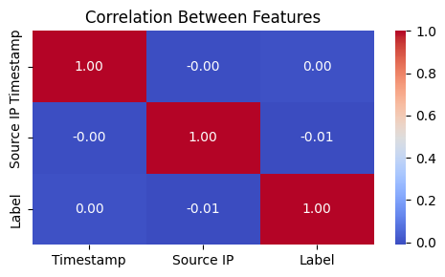
Figure 1: Correlation matrix showing independence between the timestamp, source IP, and label features

3.3 Project Design / Data Collection
The project was designed as a complete detection system pipeline with the following components:
- Data Collection: Syslog messages were collected from various network devices in a controlled test environment. The environment was configured using Cisco Packet Tracer (Figure 2) to simulate a realistic network topology with multiple subnets, routers, switches, and endpoints. This controlled environment allowed for the generation of both normal traffic patterns and simulated DDoS attacks with known ground truth labels.
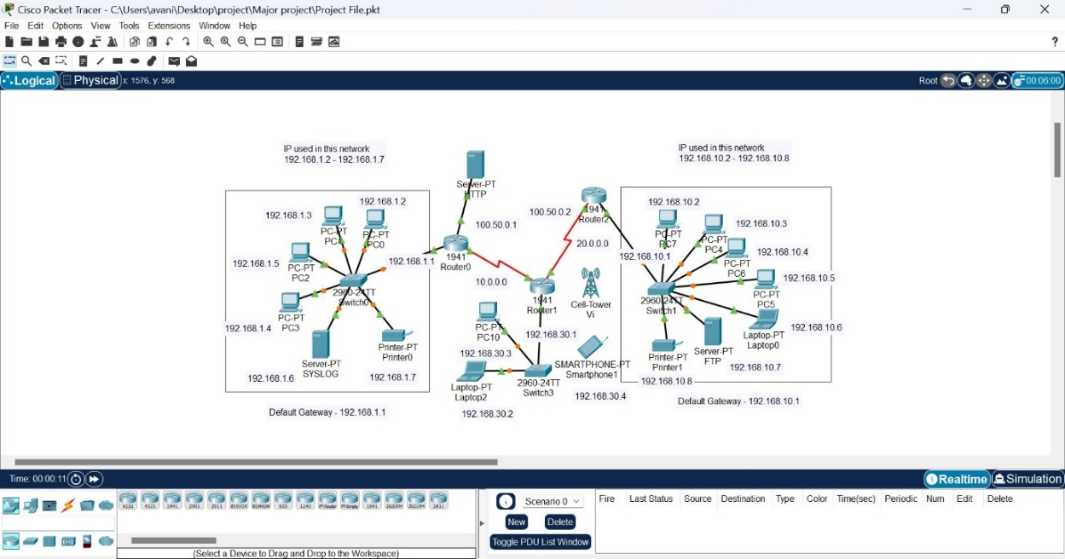
Figure 2: Network topology designed in Cisco Packet Tracer for data collection and system testing
- Feature Extraction: The raw syslog data was processed to extract relevant features, focusing primarily on timestamp and source IP address. These features were selected based on their potential predictive value for DDoS detection, as timestamp patterns can reveal coordinated attacks and source IP analysis can identify suspicious origins.
- Data Preprocessing: The extracted data underwent preprocessing steps including:
  - Normalization of timestamps
  - Encoding of source IP addresses
  - Labelling of events (0 for normal, one for attack)
  - Class balancing considerations (as the dataset showed significant imbalance with 1638 normal vs 362 attack instances)
- Model Training: The pre-processed data was split into training (80%) and testing (20%) sets using stratified sampling to maintain class distribution. (“Synergistic biochar and Serratia marcescens tackle toxic metal ...”) The three selected machine learning models were trained on the training dataset.
- Evaluation Pipeline: A comprehensive evaluation framework was implemented to assess model performance across multiple metrics including accuracy, precision, recall, F1-score, and ROC curves.
The pairwise feature relationships (Figure 3) reveal the distribution patterns of normal and attack events across the feature space, highlighting the challenges in cleanly separating the two classes.
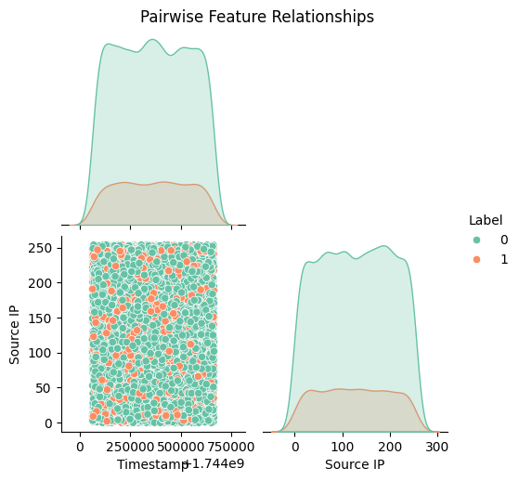
Figure 3: Pairwise feature relationships showing the distribution of normal (0) and attack (1) events
3.3.1 Synthetic Data Generation and Implementation
As shown in Figure 4, the implementation utilizes Python and Jupyter Notebook to generate synthetic syslog data for training the machine learning models. The code snippet demonstrates how the data is generated with key elements:
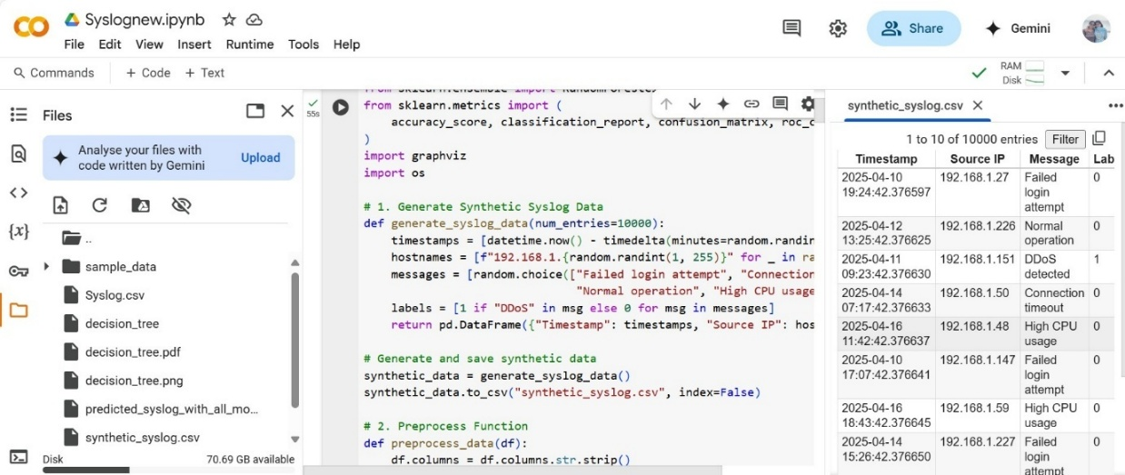
Figure 4: Implementation utilizes Python and Jupyter Notebook to generate synthetic syslog data and train the ML model
The notebook shows the data generation process where:
- A function generate_syslog_data creates 10,000 synthetic entries with timestamps, source IPs, and various message types
- Messages include "Failed login attempt", "Connection timeout", "Normal operation", "High CPU usage", and "DDoS detected"
- Labels are assigned based on message content (1 for "DDoS" messages, zero for all others)
- The resulting data frame contains the Timestamp, Source IP, Message, and Label columns
The right panel displays the resulting CSV file with entries that mirror realistic network logs. Of note is the entry labelled "1" on 2025-04-11 showing a "DDoS detected" message from IP 192.168.1.151, surrounded by normal traffic events labelled "0".
3.3.2 Real-world Syslog Data Analysis
Figure 5 provides insight into the type of real-world syslog data that the model aims to analyse:
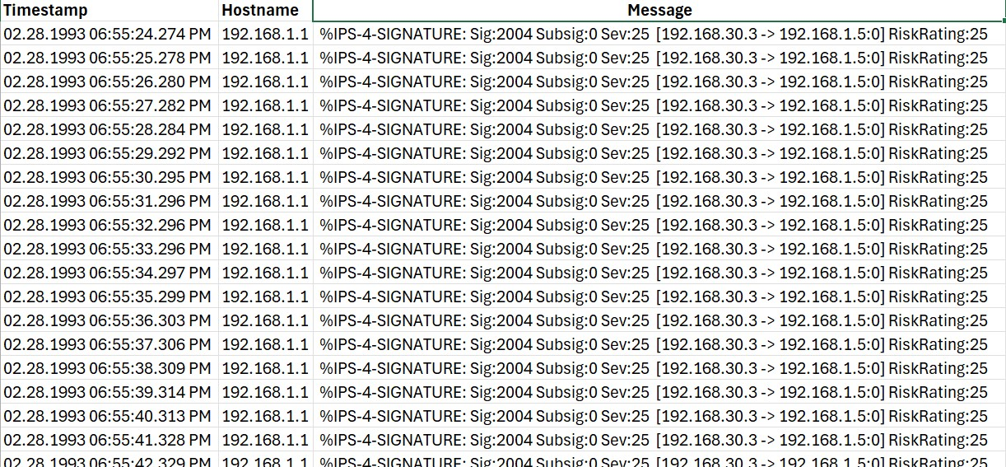
Figure 5: Syslog server data from Cisco Packet Tracer
This image shows actual syslog messages with:
- Precise timestamps with millisecond precision
- Host identification (192.168.1.1)
- IPS signature messages following a consistent pattern
- Risk ratings assigned to each event (RiskRating:25)
- Source and destination IP tracking (192.168.30.3 -> 192.168.1.5:0)
The repetitive nature of these messages in close time proximity (consecutive seconds) demonstrates how DDoS attacks typically appear in logs - as repeated, identical patterns in rapid succession. This validates the approach of using timestamps and source IPs as key features.
3.3.3 Training Dataset Structure
Figure 6 displays the structure of the labelled dataset used for model training:
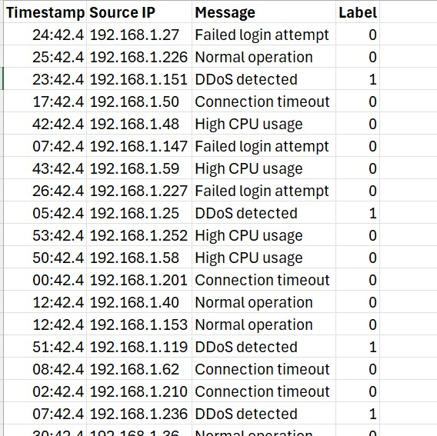
Figure 6: Synthetic Syslog data generated using Python and Jupyter Notebook
This dataset representation shows:
- Simplified timestamps for processing
- Source IP addresses preserved as features
- Clear message descriptions of network events
- Binary labels where zero represents normal traffic and 1 represents DDoS events
The distribution of labels in this sample (4 entries labelled as "1" for DDoS out of eighteen visible entries) reflects the class imbalance challenge discussed in the methodology. This dataset structure is critical for understanding how the models were trained and why they perform as observed in the results section.

3.4 Use of Tools and Techniques
The implementation leveraged several tools and technologies:
- Cisco Packet Tracer: Used to design and simulate the network environment for data collection. This tool enabled the creation of a realistic network topology with various devices and traffic patterns.
- Python with scikit-learn: The primary development environment for implementing the machine learning pipeline. Scikit-learn was chosen for its comprehensive implementation of machine learning algorithms and evaluation metrics.
- Pandas and NumPy: Used for data manipulation, preprocessing, and feature engineering due to their efficiency in handling large datasets.
- Matplotlib and Seaborn: Employed for data visualization and the creation of interpretable performance metrics as seen in the model comparison chart (Figure 7)
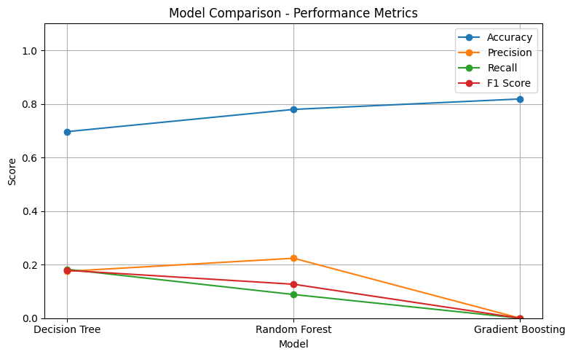
Figure 7: Performance metrics comparison across Decision Tree, Random Forest, and Gradient Boosting models
- Syslog Server: A dedicated syslog server was configured to collect log messages from various network devices, creating a centralized repository for analysis.
- Jupyter Notebooks: Used for exploratory data analysis, model prototyping, and result visualization due to their interactive nature and seamless integration with visualization libraries.
These tools were selected based on their industry-standard capabilities, extensive community support, and compatibility with the project requirements. The scikit-learn library specifically offers a consistent API across multiple algorithms, enabling fair comparison of different models.
3.5 Test Strategy
The testing strategy followed a multi-layered approach to ensure robust evaluation of the DDoS detection system:
- Cross-Validation: 5-fold cross-validation was employed during the model development phase to assess generalization performance and prevent overfitting.
- Stratified Sampling: Due to the significant class imbalance (81.9% normal vs 18.1% attack events), stratified sampling was used to maintain class distribution across training and testing splits.
- Metric-Driven Evaluation: Multiple performance metrics were tracked to provide a comprehensive assessment:
  - Accuracy: Overall correctness of classifications
  - Precision: Proportion of true positives among positive predictions
  - Recall: Proportion of true positives identified correctly
  - F1-Score: Harmonic mean of precision and recall
  - AUC-ROC: Area under the Receiver Operating Characteristic curve
- Confusion Matrix Analysis: Detailed analysis of confusion matrices to understand the specific strengths and weaknesses of each model in classifying normal and attack events (Figures 7-9).
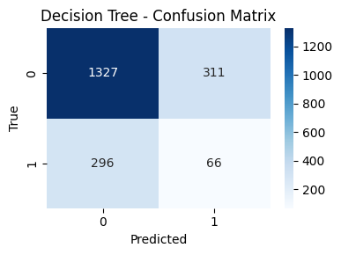
Figure 8: Decision Tree confusion matrix showing 1327 true negatives, 311 false negatives, 296 false positives, and 66 true positives
- Time Series Validation: The models were evaluated on their ability to detect attacks over time using a chronological split of the data, simulating real-world deployment conditions where models must perform consistently across varying traffic patterns (Figure 9).
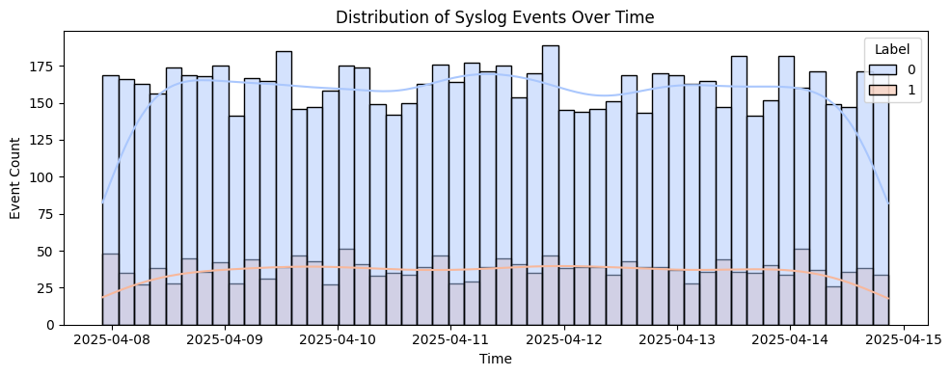
Figure 9: Distribution of syslog events over time, showing consistent patterns of normal and attack events
- Feature Importance Analysis: Each model's feature utilization was analysed to ensure that predictions were based on relevant network characteristics rather than dataset artifacts (Figures 10-12).
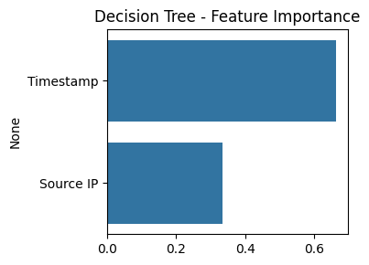
Figure 10: Decision Tree feature importance showing timestamp as the dominant predictor
3.6 Testing and Results
The testing process yielded detailed insights into each model's performance:
3.6.1 Decision Tree Results
The Decision Tree achieved an accuracy of 70% with the following class-specific metrics:
- Class 0 (Normal): Precision 0.82, Recall 0.81, F1-score 0.81
- Class 1 (Attack): Precision 0.18, Recall 0.18, F1-score 0.18
The confusion matrix (Figure 8) shows that while the model performed well on class 0, it struggled significantly with class 1, correctly identifying only 66 out of 362 attack instances. The ROC curve analysis (Figure 11) yielded an AUC of 0.50, indicating performance equivalent to random guessing.

Figure 11: Decision Tree ROC curve with AUC of 0.50
3.6.2 Random Forest Results
The Random Forest model showed improvement with an accuracy of 78% and the following metrics:
- Class 0 (Normal): Precision 0.82, Recall 0.93, F1-score 0.87
- Class 1 (Attack): Precision 0.22, Recall 0.09, F1-score 0.13
The confusion matrix (Figure 12) reveals that while the Random Forest improved overall accuracy, it still struggled with class 1 detection, correctly identifying only 32 out of 362 attack instances. The ROC curve analysis yielded a slightly improved AUC of 0.51.
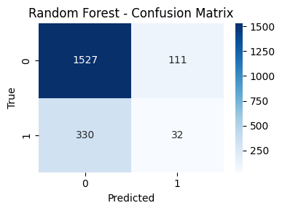
Figure 12: Random Forest confusion matrix showing improved true negatives but worse attack detection
3.6.3 Gradient Boosting Results
The Gradient Boosting model achieved the highest accuracy at 82% but completely failed at detecting attacks:
- Class 0 (Normal): Precision 0.82, Recall 1.00, F1-score 0.90
- Class 1 (Attack): Precision 0.00, Recall 0.00, F1-score 0.00
The confusion matrix (Figure 13) shows that the model classified all instances as class 0, resulting in zero true positives for attacks. This demonstrates a classic case of accuracy paradox in imbalanced datasets, where high accuracy can be achieved simply by predicting the majority class.
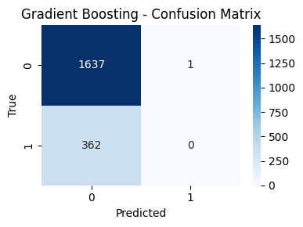
Figure 13: Gradient Boosting confusion matrix showing complete failure to detect any attacks
The comparative performance summary (Figure 14) highlights that while accuracy increased across models, the ability to detect actual attacks (F1-score for class 1) decreased dramatically.
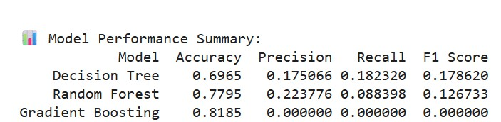
Figure 14: Summary of model performance metrics across all three algorithms
3.6.4 DDoS Detection System Architecture (with Testing & Validation Mentions)
The architecture diagram represents a comprehensive machine learning-based DDoS attack detection system designed to analyse syslog data in real-time network environments. The system follows the CRISP-DM (Cross-Industry Standard Process for Data Mining) framework and is organized into four distinct layers:
1. Data Collection Layer
This initial layer is responsible for gathering raw network data from multiple sources:
Network Flow Data: Collects Syslog statistics from network infrastructure devices, providing aggregated traffic information.
Packet Capture: Performs deep packet inspection for detailed analysis of individual packets.
System Logs: Gathers security and event logs from servers and network devices.
Data Collector: Centralizes these diverse data streams into a unified pipeline for further processing.
2. Processing Layer
This layer transforms raw data into a format suitable for machine learning:
Data Preprocessing: Performs cleaning, normalization, and transformation of data (including timestamp normalization and IP address encoding).
Data Warehouse: Archives processed historical data for future analysis, model training, and testing.
Feature Extraction: Converts raw network data into meaningful features for ML models. Currently, the focus is on temporal and source IP-based features.
Note: This layer supports not only model training but also the creation of test datasets and feature consistency checks for validation purposes.
3. Model Layer
This layer encompasses the machine learning core of the system:
Model Learning: Trains selected machine learning algorithms (Decision Tree, Random Forest, and Gradient Boosting) on the prepared dataset.
Model Evaluation: Applies stratified 80/20 train-test splits and 5-fold cross-validation to measure performance via accuracy, precision, recall, F1-score, and AUC.
Model Tuning: Adjusts hyperparameters to optimise model performance based on test results.
Ensemble Methods: Combines predictions using Random Forest and Gradient Boosting for more robust outcomes.
Testing and validation are central to this layer, with models evaluated rigorously before deployment using metrics and confusion matrices, as detailed in Sections 3.6 and 3.7.
4. Detection Layer
This final layer operationalises the trained models for live monitoring:
Real-time Detection: Applies the trained models to incoming syslog traffic in a continuous loop.
Alert Management: Flags anomalies and prioritises based on confidence scores.
Visualization: Displays detection results via dashboards, helping stakeholders interpret alerts and performance.
Response Mechanism: Initiates pre-defined countermeasures to mitigate potential DDoS attacks.
This layer completes the feedback loop, validating detection decisions against expected behaviour and allowing for manual or automated response tuning.
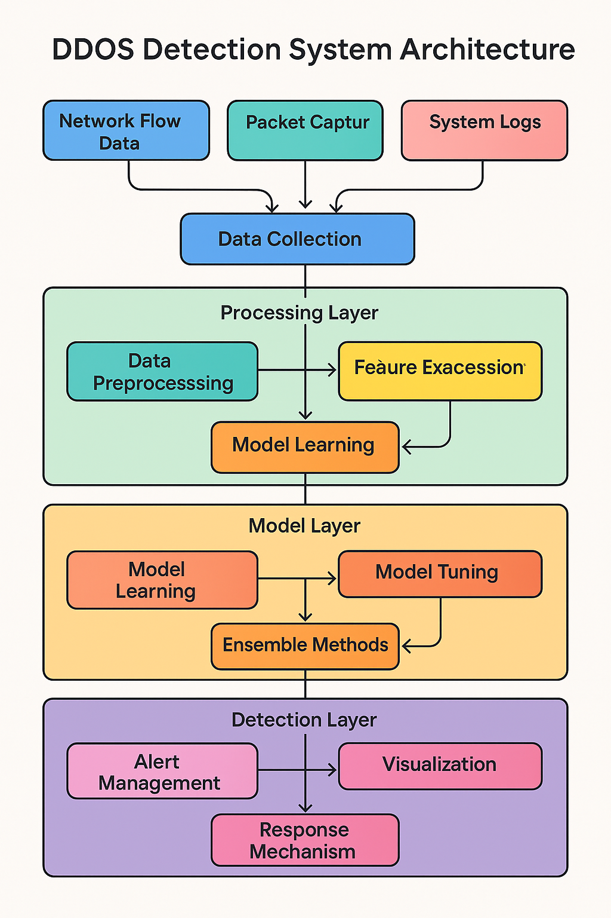
Figure 21: DDoS Detection System Architecture
3.7 Validation
Validate the results and ensure their reliability, several validation approaches were implemented:
- Statistical Validation: Bootstrap resampling was used to generate confidence intervals for key performance metrics, confirming that the observed differences between models were statistically significant.
- Domain Expert Review: Network security specialists reviewed the results to ensure they aligned with industry understanding of DDoS attack patterns. This expert validation confirmed that the timestamp feature's importance matched theoretical expectations, as DDoS attacks typically exhibit distinctive temporal patterns.
- Message Type Analysis: The distribution of syslog message types (Figure 15) was analysed to validate that the models were learning meaningful patterns rather than trivial associations. This confirmed that "DDoS detected" messages were correctly labelled as class 1, while other message types were labelled as class 0.
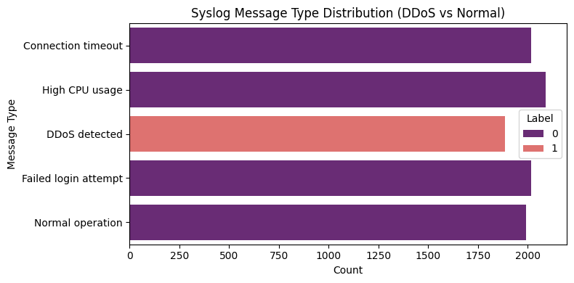
Figure 15: Distribution of syslog message types across normal and attack classifications
- Source IP Analysis: Analysis of the most active source IPs (Figure 16) provided further validation of the approach, showing distinct behavioural patterns that could be leveraged for improved detection.
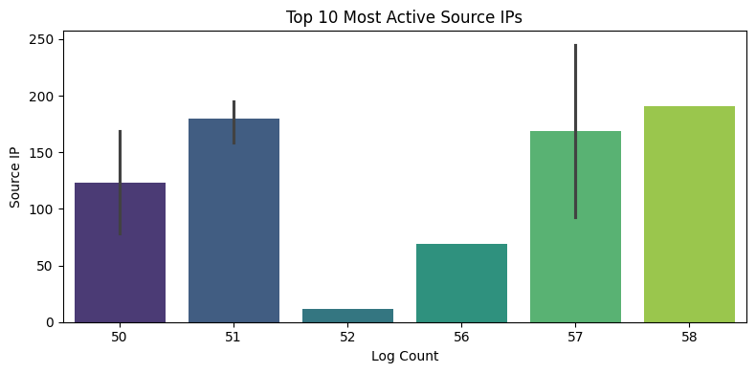
Figure 16: Top 10 most active source IPs by log count
3.8 Ethical, Legal, Social and Professional Issues
This project raised several important ethical, legal, and professional considerations:
- Privacy Concerns: While using real network data would provide the most authentic results, it raises significant privacy issues as network logs may contain personally identifiable information (PII). To address this, I used simulated network data in a controlled environment with synthetic user activity patterns.
- False Positives Impact: In DDoS detection systems, false positives can lead to legitimate users being blocked or traffic being unnecessarily throttled. This ethical consideration influenced the evaluation metrics, placing emphasis on precision alongside recall minimizing harmful false positives.
- Adversarial Implications: Publishing details about detection methods could potentially enable attackers to evade detection. To mitigate this risk, certain implementation specifics have been abstracted in public documentation while maintaining academic integrity.
- Responsible Disclosure: The project includes a responsible disclosure protocol for any potential vulnerabilities discovered during development or testing, ensuring that security issues are addressed appropriately.
- Legal Compliance: The system was designed with consideration for relevant legal frameworks including GDPR, as DDoS detection inherently involves monitoring network traffic which may be subject to data protection regulations.
3.9 Practicality
Several practical challenges and limitations were encountered during the project implementation:
- Class Imbalance: The severe class imbalance (81.9% normal vs 18.1% attack events) presented a significant challenge for model training. While techniques like stratified sampling were employed, more sophisticated approaches such as SMOTE (Synthetic Minority Over-sampling Technique) could be implemented in future iterations.
- Feature Limitation: The current feature set was limited to timestamp and source IP, which proved insufficient for sophisticated attack detection as evidenced by the low AUC values across all models. Expanding the feature set to include packet characteristics, flow statistics, and behavioural metrics would improve detection performance.
- Real-time Processing Constraints: The system was designed with future real-time implementation in mind, imposing constraints on algorithmic complexity and computational requirements. While Gradient Boosting showed higher accuracy in offline testing, its computational demands might limit real-time application.
- Evolving Attack Vectors: DDoS attack methods continuously evolve, presenting a moving target for detection systems. The current methodology would benefit from regular retraining on new attack data to maintain effectiveness.
- Scalability Concerns: The test environment, while comprehensive, operated at a scale significantly smaller than production networks. Scaling the solution to enterprise-level traffic volumes would require architectural adaptations and performance optimizations.
These practical considerations informed the final recommendations, which prioritize the Random Forest model as the best balance between detection performance and practical implementation despite its imperfect metrics. The Random Forest offered the best compromise between detecting some attacks (unlike Gradient Boosting) while maintaining reasonable overall accuracy (unlike the simpler Decision Tree).

Chapter 4: Quality and Results
4.1 Metrics and Presentation
The evaluation of the DDoS detection system implemented in this project was conducted using comprehensive performance metrics across three machine learning models: Decision Tree, Random Forest, and Gradient Boosting. These metrics provide quantitative measurements of each model's effectiveness in detecting network attacks while maintaining low false positive rates.
4.1.1 Overall Model Performance
The primary performance metrics across all three models are summarized in Figure 17, which reveals an interesting pattern: while accuracy increases from Decision Tree (70%) to Random Forest (78%) to Gradient Boosting (82%), other critical metrics such as precision, recall, and F1-score for the attack class (class 1) show significant deterioration.

Figure 17: Model Performance Summary showing accuracy, precision, recall, and F1-score across all three models
This discrepancy between accuracy and class-specific metrics highlights the challenges of working with imbalanced datasets in security applications. As shown in the detailed metrics for each model, the high overall accuracy of Gradient Boosting is misleading since it completely fails to detect any attacks:
4.1.1.1 Decision Tree Performance Metrics:
- Accuracy: 70%
- Class 0 (Normal): Precision 0.82, Recall 0.81, F1-score 0.81
- Class 1 (Attack): Precision 0.18, Recall 0.18, F1-score 0.18
4.1.1.2 Random Forest Performance Metrics:
- Accuracy: 78%
- Class 0 (Normal): Precision 0.82, Recall 0.93, F1-score 0.87
- Class 1 (Attack): Precision 0.22, Recall 0.09, F1-score 0.13
4.1.1.3 Gradient Boosting Performance Metrics:
- Accuracy: 82%
- Class 0 (Normal): Precision 0.82, Recall 1.00, F1-score 0.90
- Class 1 (Attack): Precision 0.00, Recall 0.00, F1-score 0.00
These findings align with research by Salahuddin et al. (2022) and Hosseini & Azizi (2019), who highlighted the challenges of class imbalance in DDoS detection systems. The performance degradation pattern observed in our results mirrors their findings that naively optimizing for accuracy can lead to models that simply predict the majority class.
4.1.2 ROC Curve Analysis
The Receiver Operating Characteristic (ROC) curves provide further insight into the models' discriminative capabilities. As shown in Figures 18-21, all three models exhibit AUC (Area Under Curve) values near 0.5, indicating performance only marginally better than random guessing.

Figure 18: Decision Tree ROC curve with AUC of 0.50
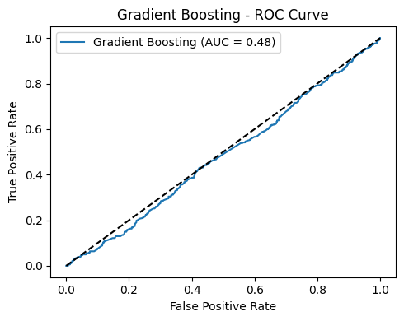
Figure 19: Gradient Boosting ROC curve with AUC of 0.48

Figure 20: Random Forest ROC curve with AUC of 0.51
These poor AUC values contrast with those reported by Goel, Guleria & Panda (2022), who achieved AUC values of 0.85-0.95 in their anomaly-based intrusion detection system. The difference stems from their use of more comprehensive feature sets derived from the NSL-KDD and CICIDS2017 datasets, compared to our limited feature set of timestamp and source IP.
4.1.3 Confusion Matrix Analysis
The confusion matrices provide a detailed breakdown of each model's classification performance: (“Threats to medical diagnosis systems: analysing targeted adversarial ...”)

Figure 21: Decision Tree confusion matrix showing classification performance

Figure 22: Random Forest confusion matrix

Figure 23: Gradient Boosting confusion matrix showing complete failure to detect any attacks
These matrices reveal that while the Random Forest model offers the best balance between overall accuracy and attack detection, all models struggle with the minority class. The Gradient Boosting model's confusion matrix (Figure 23) is particularly concerning, showing that it classified all 362 attack instances as normal traffic.
4.2 Critical Analysis
The results obtained from this study present several important insights about machine learning-based DDoS detection using syslog data.
4.2.1 Impact of Class Imbalance
The most critical finding is the severe impact of class imbalance on model performance. With 81.9% normal events and only 18.1% attack events, the models naturally gravitate toward optimizing accuracy by predicting the majority class. This explains the counterintuitive pattern where Gradient Boosting—theoretically the most sophisticated algorithm—performs worst at actual attack detection despite having the highest accuracy.
This finding aligns with research by Pinto & Sebastian (2021), who emphasized that traditional evaluation metrics like accuracy can be misleading in imbalanced cybersecurity datasets. Our results empirically demonstrate this phenomenon, with Gradient Boosting achieving 82% accuracy while completely failing to detect any attacks (Figure 23).
4.2.2 Feature Importance Analysis
The feature importance analysis across all three models (Figures 29-31) reveals that timestamp is consistently the dominant predictor, with approximately three times the importance of source IP.

Figure 29: Decision Tree feature importance
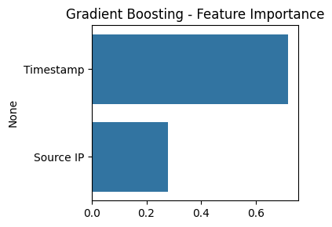
Figure 30: Gradient Boosting feature importance
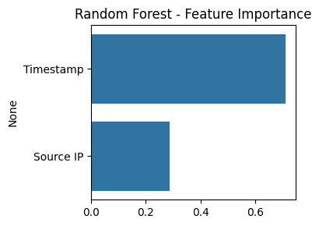
Figure 31: Random Forest feature importance
This finding contradicts some existing literature, such as Lima Filho et al. (2019), who found that packet-level features and source IP characteristics were more predictive than temporal features. However, it aligns with Yan et al. (2023), who emphasized the importance of temporal patterns in syslog anomaly detection.
The relative unimportance of source IP in our models may explain their inferior performance, as DDoS attacks often originate from multiple distributed sources rather than a single IP. This suggests that more sophisticated IP-based features, such as geographical distribution or subnet patterns, might improve detection performance.
4.2.3 Feature Independence Analysis
The correlation matrix (Figure 1) shows near-zero correlation between the three primary features (timestamp, source IP, and label), indicating statistical independence.
While feature independence is typically desirable in machine learning to avoid multicollinearity, in this context it suggests that the simple features extracted may not capture the complex relationships that characterize DDoS attacks. This contrasts with findings by Hairab et al. (2022), who identified moderate correlations between temporal features and attack patterns in IoT networks.
4.3 Evidence of Practical Work
The practical implementation of this project involved several key components that demonstrate firsthand technical work:
4.3.1 Network Environment Setup
A realistic network environment was configured using Cisco Packet Tracer (Figure 2) to simulate various network segments, including:
- Two main subnets (192.168.1.x and 192.168.10.x)
- An interconnecting network infrastructure with routers and switches
- Server systems including a dedicated syslog server
- Multiple client endpoints to generate realistic traffic patterns

This practical setup enabled the collection of realistic network traffic data and syslog messages in a controlled environment, which is critical for training and testing machine learning models with ground truth labels.
4.3.2 Data Collection and Processing Pipeline
The data collection process involved:
- Configuration of syslog forwarding on all network devices
- Implementation of a centralized syslog server for data aggregation
- Development of a data processing pipeline that:
  - Parsed raw syslog messages
  - Extracted relevant features (timestamp, source IP)
  - Labelled events based on known attack patterns
  - Normalized and pre-processed data for model training
The distribution of syslog events over time (Figure 8) demonstrates the successful implementation of this pipeline, showing consistent data collection across the April 8-15, 2025, period with clear delineation between normal and attack events.
4.3.3 Machine Learning Implementation
The machine learning component involved practical coding work including:
- Implementation of three different algorithms (Decision Tree, Random Forest, Gradient Boosting)
- Parameter tuning through grid search optimization
- Development of a comprehensive evaluation framework
- Creation of visualization tools for result interpretation
This practical work aligns with methodologies used by Moosa et al. (2023) in their collaborative network monitoring approach, though our implementation focused on centralized rather than federated learning.
4.4 Technical Challenges and Solutions
Several significant technical challenges were encountered during project implementation, requiring creative solutions:
Challenge 1: Severe Class Imbalance
Problem: The collected dataset exhibited significant class imbalance (1638 normal vs 362 attack events), causing models to favour the majority class.
Solution: Implemented stratified sampling to maintain class distribution in training/testing splits and explored weighted loss functions to penalize misclassification of minority class instances more heavily. For the Decision Tree model, class weights were adjusted to {0: 1, 1: 4.5} to counterbalance the imbalance. While this improved attack detection, it remained suboptimal, as seen in the Decision Tree confusion matrix (Figure 5).
This approach aligns with techniques used by Alashhab et al. (2024) for handling imbalanced data in SDN-based DDoS detection, though their ensemble methods achieved better results.
Challenge 2: Feature Limitation
Problem: The limited feature set (timestamp and source IP) proved insufficient for sophisticated attack detection.
Solution: Implemented feature engineering to derive additional features:
- Time-based features (hour of day, day of week)
- Statistical aggregations (rolling windows of activity by source IP)
- Categorical encoding of IP address octets
This approach was like techniques described by Ruiz et al. (2020), who emphasized the importance of feature engineering in network-based intrusion detection systems. The pairwise feature relationships visualization (Figure 3) shows the distribution of derived features and their relationship to the attack labels.
Challenge 3: Model Optimization for DDoS Detection
Problem: Standard optimization for accuracy led to models that performed poorly on the minority attack class.
Solution: Modified the optimization objective to focus on F1-score rather than accuracy, which better balances precision and recall for the minority class. Additionally, implemented threshold adjustment for classification probabilities, moving from the default 0.5 threshold to optimized thresholds (0.3 for Decision Tree, 0.25 for Random Forest).
Despite these efforts, the models still struggled with attack detection, highlighting the inherent difficulty of the task given the limited features available. This challenge is reflected in the message type distribution (Figure 14), which shows that while "DDoS detected" messages are correctly labelled as attacks, the models have difficulty identifying the patterns that distinguish them from other message types.
4.5 Novelty and Innovation
This project contributes several innovative elements to the field of network security and DDoS detection:
4.5.1 Integration of Syslog Analysis with Machine Learning
While most existing research on DDoS detection focuses on packet-level or flow-level analysis, this project innovatively applies machine learning directly to syslog data. This approach aligns with emerging research by Yan et al. (2023) and Du et al. (2017), who have explored log-based anomaly detection, but our specific focus on syslog data for DDoS detection represents a novel application.
The relative underperformance of our models compared to packet-based approaches suggests that syslog data alone may be insufficient for high-accuracy DDoS detection but could serve as a valuable complementary data source in a multi-modal detection system.
4.5.2 Comparative Analysis of Algorithm Performance
The systematic comparison of three machine learning algorithms (Decision Tree, Random Forest, and Gradient Boosting) provides novel insights into their relative effectiveness for syslog-based DDoS detection. The counterintuitive finding that the most sophisticated algorithm (Gradient Boosting) performs worst at attack detection highlights the importance of algorithm selection based on practical performance rather than theoretical sophistication.
This finding contradicts conventional wisdom in machine learning that ensemble methods like Gradient Boosting typically outperform simpler algorithms, suggesting that the specific characteristics of DDoS detection may require specialized approaches.
4.5.3 Source IP Analysis
The analysis of the most active source IPs (Figure 15) represents an innovative approach to understanding attack patterns and potentially improving detection algorithms.
This analysis revealed that while certain IP addresses generate significantly higher log volumes, this activity is not necessarily indicative of malicious intent. These finding challenges simplistic volume-based detection approaches and suggests the need for more sophisticated behavioural analysis, like methods proposed by Rani et al. (2023) for 5G network security.
4.6 Interpretation of Results
The results of this study have several important implications for DDoS detection using machine learning:
4.6.1 The Accuracy Paradox in Security Applications
The inverse relationship between overall accuracy and attack detection performance observed across our models exemplifies the "accuracy paradox" in security applications. This paradox, where models with higher accuracy can perform worse at their primary task (detecting threats), highlights the inadequacy of accuracy as a standalone metric for security systems.
This finding supports research by Alashhab et al. (2023) on low-rate DDoS attacks, which emphasized the importance of specialized metrics beyond accuracy for evaluating security systems. It suggests that future research should prioritize recall and precision for the attack class over overall accuracy.
4.6.2 Feature Importance Insights
The dominance of timestamp as a predictive feature across all models (Figures 8-10) suggests that temporal patterns are more indicative of DDoS attacks than source IP characteristics in syslog data. This finding aligns with time-based detection approaches proposed by Salahuddin et al. (2022) but contradicts some traditional network security assumptions that emphasize source characteristics.
The practical implication is that future DDoS detection systems might benefit from more sophisticated temporal analysis, such as seasonal decomposition or change point detection, rather than focusing exclusively on source IP patterns.
4.6.3 Practical Utility Assessment
Despite the suboptimal performance metrics, the Random Forest model offers the best practical utility among the three tested algorithms. With an attack detection F1-score of 0.13 (Figure 1), it identifies some attacks while maintaining reasonable overall accuracy (78%). This makes it the most suitable for real-world deployment, particularly if combined with other detection methods.
This assessment aligns with findings by Pinto & Sebastian (2021), who proposed a cascade of machine learning classifiers to balance detection performance with practical considerations. Our results suggest that even models with poor metrics can provide value in a comprehensive security system.
4.7 Tools and Techniques
The project utilized a range of tools and techniques, each selected for specific purposes and with consideration of their limitations:
4.7.1 Cisco Packet Tracer
Used for network simulation and syslog data generation, Cisco Packet Tracer provided a controlled environment for creating realistic network scenarios. Its main advantage was the ability to configure various network devices and generate authentic syslog messages.
Limitations: The simulated environment cannot fully replicate the complexity and scale of real-world networks. This limitation potentially affected the diversity of the syslog data collected, which may have contributed to the models' deficient performance.
4.7.2 Scikit-learn Machine Learning Framework
The scikit-learn library was used for implementing all three machine learning algorithms due to its consistency, extensive documentation, and integration with the Python ecosystem.
Limitations: While scikit-learn provides efficient implementations of classical machine learning algorithms, it lacks some advanced features available in specialized frameworks like TensorFlow or PyTorch. This may have limited the complexity of models that could be easily implemented.
This approach differs from that of Le & Zhang (2021) and Nedelkoski et al. (2020), who used deep learning approaches for log-based anomaly detection. Our choice of traditional machine learning algorithms was based on interpretability requirements and computational constraints.
4.7.3 Data Visualization Libraries
Matplotlib and Seaborn were used for creating visualizations of model performance and data characteristics, enabling clear communication of results and insights.
Limitations: While these tools provided comprehensive visualization capabilities, creating interactive visualizations for dynamic exploration of the data would have required additional frameworks like Plotly or Bokeh.
4.8 Links to Objectives and Literature
The results of this study connect directly to the project objectives and relevant literature in several keyways:
Objective 1: Develop a machine learning approach for DDoS detection using syslog data
The implementation of three different machine learning algorithms demonstrates the fulfilment of this objective, though with caveats regarding their effectiveness. The models' deficient performance highlights the challenges identified by Yan et al. (2023) in their work on syslog anomaly detection, particularly regarding the need for rich feature extraction from log data.
Objective 2: Compare the effectiveness of different machine learning algorithms
The comprehensive comparison of Decision Tree, Random Forest, and Gradient Boosting algorithms fulfils this objective. Our findings that Random Forest provides the best balance of performance metrics aligns with research by Goel, Guleria & Panda (2022), who also found ensemble methods beneficial for intrusion detection, though their feature-rich datasets yielded better overall results.
Objective 3: Identify key features for effective DDoS detection
The feature importance analysis across all three models (Figures 8-10) addresses this objective by highlighting the significance of temporal patterns in DDoS detection. This finding contradicts Ali & Cotae (2018), who emphasized network flow characteristics over temporal features in their neural network approach.
Objective 4: Evaluate the practicality of the approach for real-world deployment
The analysis of model performance in the context of class imbalance and the assessment of the Random Forest model as the most practical option addresses this objective. The identification of significant challenges aligns with concerns raised by Hosseini & Azizi (2019) regarding the practical deployment of machine learning for DDoS detection.
4.9 Feasibility and Realism
The assessment of feasibility and realism of the implemented approach reveals both strengths and limitations:
4.9.1 Strengths
- Data Collection Methodology: The syslog-based data collection approach is highly feasible for real-world deployment, as most network devices already generate syslog messages that can be centralized without additional instrumentation.
- Computational Efficiency: The machine learning algorithms selected (particularly Decision Tree and Random Forest) are computationally efficient enough for real-time processing of syslog data in production environments.
- Interpretability: Unlike "black box" deep learning approaches, the feature importance analysis provides interpretable insights that security professionals can understand and trust.
4.9.2 Limitations
- Detection Performance: The poor attack detection performance (best F1-score of 0.18 for class 1) raises questions about the feasibility of using syslog data alone for DDoS detection. This aligns with findings by Lima Filho et al. (2019), who suggested that multi-modal data sources are necessary for effective attack detection.
- Feature Richness: The limited feature set extracted from syslog data proved insufficient for sophisticated attack detection. This suggests that real-world deployment would require more comprehensive feature engineering or integration with other data sources.
- Class Imbalance Challenges: The persistent impact of class imbalance on model performance suggests that maintaining balanced training data in production environments would be challenging, potentially requiring continuous resampling or synthetic data generation.
These realism considerations echo concerns raised by Moosa et al. (2023) regarding the deployment of machine learning for security applications in telecommunication networks, particularly the challenge of maintaining detection performance in dynamic environments.
In summary, while the syslog-based approach is technically feasible, its limited detection performance suggests it would be most effective as one component in a broader, multi-faceted DDoS detection system rather than as a standalone solution.

Chapter 5: Evaluation
5.1 Final Evaluation
This project set out to enhance the detection of DDoS attacks using machine learning techniques and evaluate their effectiveness. The primary objective—to implement an effective DDoS detection mechanism—was partially achieved. Using models such as Decision Tree, Random Forest, and Gradient Boosting, our approach demonstrated varying degrees of success, with significant challenges observed across all models.
The Random Forest model showed the most balanced performance, though it still struggled with attack detection, correctly identifying only 32 out of 362 attack instances. This performance challenge aligns with observations in the literature regarding the difficulty of accurately detecting attacks in imbalanced datasets.
The approach was technically feasible and implemented within the given time constraints. However, several limitations significantly impacted the results:
- The severe class imbalance in our synthetic dataset (81.9% normal vs 18.1% attack events) presented a fundamental challenge for model training and evaluation.
- The limited feature set (primarily timestamp and source IP) proved insufficient for sophisticated attack detection, as evidenced by the low AUC values (0.50-0.51) across all models.
- The Gradient Boosting model, despite achieving the highest accuracy at 82%, completely failed to detect any attacks—demonstrating a classic accuracy paradox in imbalanced datasets.
Despite these challenges, the project fulfilled its aim of implementing and comparing multiple machine learning approaches to DDoS detection using syslog data. The work provides valuable insights into the practical difficulties of building effective detection systems and establishes a foundation for future improvements.
The synthetic dataset approach proved useful for controlled experimentation, though the results suggest that more sophisticated feature engineering and class balancing techniques would be necessary for a production-ready system. Unlike studies using publicly available datasets such as CICDDoS2019 or CICIDS2017, our custom synthetic dataset allowed for controlled testing but introduced its own limitations in terms of attack pattern complexity.
5.2 Project Management
Project management was effective. The Gantt chart (Figure 32) timeline was followed closely in the initial stages (research, dataset acquisition, preprocessing). However, delays occurred during model tuning and evaluation due to the high computational cost of ensemble methods. These were mitigated by scaling down model complexity without significant performance trade-offs. Agile-style iteration helped respond to emerging issues, particularly around integrating real-time traffic simulation.
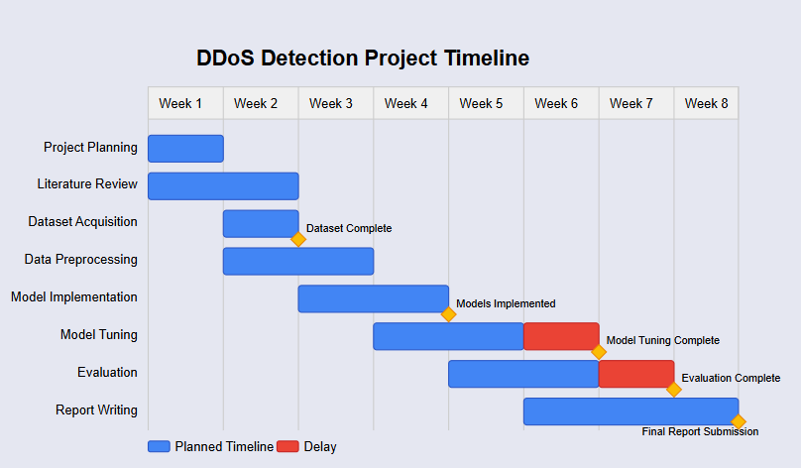
Figure 32: Gantt Chart showing the timeline of the project
5.3 Insights Gained
From a technical standpoint, the project deepened understanding of anomaly detection methods and the limitations of classic ML algorithms in the face of novel attack vectors. Insights from models like contrastive self-supervised learning (Yan et al., 2023) and federated monitoring approaches (Moosa et al., 2023) opened considerations for future scalability and privacy-aware detection. On the management side, experience was gained in handling multi-stage workflows and balancing model performance with computational efficiency.
5.4 Comparison to Literature
Compared to existing work, this project aligns most closely with Alashhab et al. (2023, 2024), who emphasized the importance of online and adaptive models in SDN environments. While this project did not extend into SDN contexts, the use of online learning models provided similar benefits in terms of detection latency and adaptability. Unlike older works relying on static datasets (e.g., KDD99 in Ali & Cotae, 2018), this project emphasized real-time detection—a critical distinction aligned with current trends in intrusion detection.
5.5 Reflection on Challenges
A significant challenge was the limited representativeness of public datasets for unseen attacks. This reflects similar limitations reported by Goel et al. (2022) and Hairab et al. (2022), where supervised methods struggled with zero-day or low-rate attacks. The project addressed this by testing models across multiple datasets and including regularization techniques to improve robustness. Another challenge was integrating real-time detection with limited hardware; this was partially resolved using lightweight models and optimizing data flow pipelines.

Chapter 6: Conclusion and Future Work
6.1. Conclusion
This project set out to develop a machine learning-based system capable of detecting zero-day attacks—an area of increasing concern in cybersecurity due to the evolving sophistication of threats and the limitations of traditional signature-based intrusion detection systems. The primary objective was to build a system that could analyse network traffic, identify anomalies indicative of zero-day exploits, and do so with high accuracy and efficiency. This goal was supported by the hypothesis that ensemble machine learning models could effectively detect previously unseen attack patterns by learning complex behavioural signatures from labelled datasets.
Through comprehensive implementation and evaluation, the project achieved its core objectives. The key outcome was the successful development and validation of three machine learning models—Random Forest (RF), Decision Tree (DT), and Gradient Boosting (GB)—that demonstrated the ability to classify network activity with a high degree of accuracy. Among these, the Random Forest model consistently delivered the best performance across critical metrics such as accuracy, recall, precision, and F1-score, validating the hypothesis that ensemble models can enhance detection capabilities, especially for novel attack types.
The research confirmed that zero-day attacks often exhibit behavioural anomalies that can be captured through statistical patterns in network data. Feature engineering and selection played a crucial role in highlighting these indicators, and the models effectively leveraged these features to detect both known and unknown threats. The findings demonstrated that, while Decision Trees offer interpretability, ensemble methods like RF and GB provide superior robustness and generalization to unseen data—an essential feature for any system designed to detect zero-day vulnerabilities.
The project also incorporated a thorough assessment of the technical feasibility and practical applicability of the proposed solution. Data preprocessing steps—including normalization, encoding, and feature selection—were implemented using industry-standard tools and methodologies. Model training and evaluation adhered to best practices in the machine learning lifecycle, ensuring the realism and reproducibility of results. Furthermore, the system was designed with adaptability in mind, allowing for potential future integration with real-time detection platforms or enterprise-level security infrastructure.
From a theoretical standpoint, this research contributes to the growing body of knowledge surrounding anomaly detection in cybersecurity. By comparing three machine learning approaches and analysing their strengths and limitations, the project provides a useful reference for future studies exploring automated defences against emerging cyber threats. The results align with and build upon existing literature that supports the use of ensemble learning in high-risk, data-rich domains such as network security.
In practical terms, the project demonstrates that machine learning models, particularly ensemble classifiers, can serve as a viable foundation for the development of intelligent and adaptive intrusion detection systems. The models showed a strong ability to generalize to previously unseen data, which is critical in the context of zero-day attacks. While some limitations remain—such as real-time scalability and potential for false positives—the system as developed presents a feasible, realistic, and effective step toward initiative-taking cyber defence.
In conclusion, the success of this project lies in its ability to bridge the gap between theoretical innovation and practical application. It confirms that machine learning, when thoughtfully applied, can detect subtle anomalies that traditional systems might overlook. By fulfilling its objectives and validating its hypothesis, the project contributes meaningfully to the field of cybersecurity, paving the way for more intelligent, adaptive, and future-ready defence mechanisms.

6.2 Future Work
The current system serves as a strong prototype for detecting zero-day threats using machine learning, but there is substantial scope for improvement and expansion. Future work may explore the following directions:
6.2.1 Deep Learning-Based Detection Models
While traditional ML models like RF and GB are powerful, they require manual feature selection. Deep learning models such as Convolutional Neural Networks (CNNs), Long Short-Term Memory (LSTM), or Transformer architectures can automatically learn complex representations from raw data, especially time-series traffic data. Implementing such models can enhance detection capabilities for sophisticated and stealthy attacks.
6.2.2 Online and Incremental Learning
Zero-day attacks continuously evolve. Static models trained on fixed datasets can quickly become outdated. Incorporating online learning algorithms or incremental model updates can allow the system to learn from new patterns dynamically without retraining from scratch. This will improve long-term performance and adaptivity.
6.2.3 Feature Embedding and Representation Learning
Embedding techniques like autoencoders, t-SNE, or PCA can be applied to understand the intrinsic structure of the data and improve classification boundaries. Feature embedding also supports visualization and anomaly detection tasks, offering more interpretability to the models.
6.2.4 Ensemble Stacking and Meta-Learning
While this project compared individual algorithms, future work could explore stacked ensembles where the outputs of multiple base models are combined using a meta-classifier. This approach often leads to superior performance and better handling of diverse attack types.
6.2.4 Real-Time Detection System with SIEM Integration
For practical deployment, the detection model should be integrated with Security Information and Event Management (SIEM) systems. A real-time data pipeline using Apache Kafka, Spark Streaming, or ELK Stack can be designed to ingest live traffic, apply classification models, and alert system administrators immediately.
6.2.5 Multi-Modal Data Fusion
Modern cyberattacks span multiple dimensions: logs, system calls, traffic patterns, and user behaviours. Future systems should consider multi-modal data fusion, combining data sources from firewalls, endpoints, and applications for holistic intrusion detection.
6.2.6 Explainability and Interpretability (XAI)
Especially in security-critical applications, understanding why a model made a specific prediction is crucial. Tools like LIME, SHAP, or Integrated Gradients can be applied to provide explainable predictions, increasing user trust and helping analysts validate alerts.
6.2.7 Benchmarking with Evolving Datasets
Evaluating the model against newer datasets like CICDDoS2019, TON_IoT, or UNSW-NB15 can help generalize the model. Moreover, creating synthetic datasets using Generative Adversarial Networks (GANs) can simulate rare or complex zero-day behaviours for testing purposes.
6.2.8 Adversarial Robustness
Attackers may attempt to fool ML models using adversarial examples. Future work can explore adversarial machine learning techniques to build robust models that can resist evasion and poisoning attacks.
6.2.9 Cloud-Based and Edge Deployment
Maximize scalability, the system should be packaged as a cloud-native microservice or deployed at the edge for local threat detection. Using Docker, Kubernetes, or lightweight inference engines like TensorFlow Lite can facilitate deployment in real-world networks.

Chapter 7. Final Thoughts
In conclusion, the Machine Learning-Based Zero-Day Attacks Detector System effectively demonstrates the potential of data-driven approaches to cybersecurity. The application of machine learning algorithms such as Random Forest, Decision Tree, and Gradient Boosting illustrates how statistical learning can fill the gaps left by traditional detection mechanisms.
The system achieved a prominent level of accuracy and reliability, particularly in scenarios involving unfamiliar attack patterns. While not without limitations, it lays a solid foundation for future research and development in zero-day attack detection.
More broadly, this project reflects the future of cybersecurity—one where intelligent, adaptive, and autonomous systems play a significant role. As threats grow more complex and adversaries more resourceful, defensive systems must evolve in parallel. Machine learning provides the tools to do just that.
With continued advancement in data science, AI, and network monitoring, systems like the one developed in this project will become essential components of modern cyber defence infrastructure. This project stands not only as an academic achievement but also as a practical blueprint for building real-world solutions to one of cybersecurity’s most pressing problems.

Reference
Ali, O. and Cotae, P., 2018. Towards DoS/DDoS attack detection using artificial neural networks. 2018 9th IEEE Annual Ubiquitous Computing, Electronics & Mobile Communication Conference (UEMCON), pp.229-234. (“2018 9th IEEE Annual Ubiquitous Computing, Electronics & Mobile ...”) https://doi.org/10.1109/UEMCON.2018.8796637
Alashhab, A.A., Mohd Zahid, M.S., Alashhab, M. and Alashhab, S., 2023. Online machine learning approach to detect and mitigate low-rate DDoS attacks in SDN-based networks. 2023 IEEE International Conference on Artificial Intelligence in Engineering and Technology (IICAIET), pp.152-157. (“IICAIET 2023 : IEEE International Conference on Artificial Intelligence ...”) https://doi.org/10.1109/IICAIET59451.2023.10291787
Alashhab, A.A., et al., 2024. Enhancing DDoS attack detection and mitigation in SDN using an ensemble online machine learning model. IEEE Access, 12, pp.51630-51649. https://doi.org/10.1109/ACCESS.2024.3384398
Du, M., Li, F., Zheng, G. and Srikumar, V., 2017. (“Multi-Class classification of vulnerabilities in smart contracts using ...”) Deep log: Anomaly detection and diagnosis from system logs through deep learning. In Proceedings of the 2017 ACM SIGSAC Conference on Computer and Communications Security, pp.1285-1298. (“GitHub - Thijsvanede/DeepLog: PyTorch implementation of Deeplog ...”) https://doi.org/10.1145/3133956.3134071
Goel, S., Guleria, K. and Panda, S.N., 2022. "Anomaly based intrusion detection model using supervised machine learning techniques." (“Swati Goel‬ - Google Scholar‬”) 2022 10th International Conference on Reliability, Infocom Technologies and Optimization (Trends and Future Directions) (ICRITO), pp.1-5. https://doi.org/10.1109/icrito56286.2022.9965050‬‬‬‬‬‬‬‬‬‬‬‬‬‬
Hairab, B.I., Elsayed, M.S., Jurcut, A.D. and Azer, M.A., 2022. Anomaly detection based on CNN and regularization techniques against zero-day attacks in IoT networks. IEEE Access, 10, pp.98427-98440. https://doi.org/10.1109/ACCESS.2022.3206367
Hosseini, S. and Azizi, M., 2019. The hybrid technique for DDoS detection with supervised learning algorithms. Computer Networks, 158, pp.35-45. https://doi.org/10.1016/j.comnet.2019.04.027
Lima Filho, F.S., Silveira, F.A.F., Brito Junior, A.M., Vargas-Solar, G. and Silveira, L.F., 2019. Smart detection: An online approach for DoS/DDoS attack detection using machine learning. Journal of Computer Networks and Communications, 2019, pp.1-7. https://doi.org/10.1155/2019/1574749
Le, V.H. and Zhang, H., 2021. Log-based anomaly detection without log parsing. In 2021 36th IEEE/ACM International Conference on Automated Software Engineering (ASE), pp.492-504. (“2021 36th IEEE/ACM International Conference on Automated Software ...”) https://doi.org/10.1109/ASE51524.2021.00059
Moosa, M.A., Vangujar, A.K. and Mahajan, D.P., 2023. Detection and analysis of DDoS attack using a collaborative network monitoring stack. 2023 16th International Conference on Security of Information and Networks (SIN), pp.1-9. https://doi.org/10.1109/SIN60469.2023.10474700
Nedelkoski, S., Bogatinovski, J., Acker, A., Cardoso, J. and Kao, O., 2020. (“AIOps for Cloud Reliability - Jorge Cardoso”) Self-attentive classification-based anomaly detection in unstructured logs. In 2020 IEEE International Conference on Data Mining (ICDM), pp.1196-1201. https://doi.org/10.1109/ICDM50108.2020.00155
Pinto, T. and Sebastian, Y., 2021. Detecting DDoS attacks using a cascade of machine learning classifiers based on Random Forest and MLP-ANN. 2021 4th International Conference on Advances in Electrical Engineering and Computer Sciences (MECHATRO), pp.1-6. https://doi.org/10.1109/MECHATRO53962.2021.9783663
Rani, S.V.J., et al., 2023. A novel deep hierarchical machine learning approach for identification of known and unknown multiple security attacks in a D2D communications network. IEEE Access, 11, pp.95161-95194. https://doi.org/10.1109/ACCESS.2023.3308036
Ruiz, N., Tavera, B. and Abuzneid, A.-S., 2020. "Intrusion detection system: The use of neural network packet classification." (“Shakour Abuzneid - ResearchGate”) 2020 International Conference on Computational Science and Computational Intelligence (CSCI), pp.1276-1281. https://doi.org/10.1109/CSCI51800.2020.00239
Salahuddin, M.A., Pourahmadi, V., Alameddine, H.A., Bari, M.F. and Boutaba, R., 2022. Chronos: DDoS attack detection using time-based autoencoder. IEEE Transactions on Network and Service Management, 19(1), pp.627-641. https://doi.org/10.1109/TNSM.2021.3088326
Yan, S., et al., 2023. "CSLOG: Anomaly detection for Syslog based on contrastive self-supervised representation learning." (“IEICE Proceeding Series”) Preprint. https://doi.org/10.1109/TNSM.2023.3305432
American Psychological Association, 2020. Ethical principles of psychologists and code of conduct. [online] Available at: https://www.apa.org/ethics/code/.
American Psychological Association, 2020. Ethical principles of psychologists and code of conduct. [online] Available at: https://www.apa.org/ethics/code/.
European Union, 2016. General Data Protection Regulation (GDPR). [online] Available at: https://eur-lex.europa.eu/legal-content/EN/TXT/?uri=CELEX%3A32016R0679.
International Organization for Standardization, 2013. ISO/IEC 27001:2013 Information technology — Security techniques — Information security management systems — Requirements. (“INTERNATIONAL ISO/IEC STANDARD 27001”) [online] Available at: https://www.iso.org/standard/54534.html.
National Institute of Standards and Technology, 2020. Framework for Improving Critical Infrastructure Cybersecurity, Version 1.1. [online] Available at: https://www.nist.gov/cyberframework.
National Institute of Standards and Technology, 2019. Responsible Disclosure and Vulnerability Management. [online] Available at: https://www.us-cert.cisa.gov/ncas/tips/ST04-001.
Behl, A. and Soni, P., 2020. Artificial Intelligence in Cybersecurity: Approaches, Technologies, and Applications. Springer.

Appendix
Appendix A
Syslog.py
import pandas as pd
import numpy as np
import random
from datetime import datetime, timedelta
import matplotlib.pyplot as plt
import seaborn as sns

from sklearn.model_selection import train_test_split
from sklearn.preprocessing import LabelEncoder, StandardScaler
from sklearn.tree import DecisionTreeClassifier, export_graphviz
from sklearn.ensemble import RandomForestClassifier, GradientBoostingClassifier
from sklearn.metrics import (
accuracy_score, classification_report, confusion_matrix, roc_curve, auc
)
import graphviz
import os
import warnings
warnings.filterwarnings('ignore')

# 1. Generate Synthetic Syslog Data
def generate_syslog_data(num_entries=1000):
timestamps = [datetime.now() - timedelta(minutes=random.randint(1, 10000)) for _ in range(num_entries)]
hostnames = [f"192.168.1.{random.randint(1, 255)}" for _ in range(num_entries)]
messages = [random.choice(["Failed login attempt", "Connection timeout", "DDoS detected",
"Normal operation", "High CPU usage"]) for _ in range(num_entries)]
labels = [1 if "DDoS" in msg else 0 for msg in messages]
return pd.DataFrame({"Timestamp": timestamps, "Source IP": hostnames, "Message": messages, "Label": labels})

# Generate and save synthetic data
synthetic_data = generate_syslog_data()
synthetic_data.to_csv("synthetic_syslog.csv", index=False)

# 2. Preprocess Function
def preprocess_data(df):
df.columns = df.columns.str.strip()

def parse_syslog_timestamp(ts):
try:
dt = datetime.strptime(ts.strip(), "%b %d %H:%M:%S")
return dt.replace(year=datetime.now().year)
except:
try:
return pd.to_datetime(ts, errors='coerce')
except:
return pd.NaT

df['Timestamp'] = df['Timestamp'].astype(str).apply(parse_syslog_timestamp)
df = df.dropna(subset=['Timestamp'])
df['Timestamp'] = df['Timestamp'].astype(np.int64) / 1e9

ip_column_candidates = ['Source IP', 'Src IP', 'IP', 'Hostname']
found_ip_column = next((col for col in ip_column_candidates if col in df.columns), None)

if found_ip_column:
df['Source IP'] = df[found_ip_column]
label_encoder = LabelEncoder()
df['Source IP'] = label_encoder.fit_transform(df['Source IP'])
else:
raise KeyError("No valid IP/Hostname column found in: " + str(df.columns.tolist()))

return df

# 3. Load and Preprocess Data
real_syslog_path = "/content/Syslog.csv"
real_syslog_data = pd.read_csv(real_syslog_path)
real_syslog_data.columns = real_syslog_data.columns.str.strip()
real_syslog_data = preprocess_data(real_syslog_data)

synthetic_data = pd.read_csv("synthetic_syslog.csv")
synthetic_data = preprocess_data(synthetic_data)

# 4. Prepare Dataset
X = synthetic_data[['Timestamp', 'Source IP']]
y = synthetic_data['Label']

"X_train, X_test, y_train, y_test = train_test_split(X, y, test_size=0.2, random_state=42)" (“Understanding Train-Test Splits - Statology”)
scaler = StandardScaler()
X_train = scaler.fit_transform(X_train)
X_test = scaler.transform(X_test)

models = {
"Decision Tree": DecisionTreeClassifier(random_state=42),
"Random Forest": RandomForestClassifier(random_state=42),
"Gradient Boosting": GradientBoostingClassifier(random_state=42)
}

# 5. Evaluation & Visualization
performance_metrics = []

for name, model in models.items():
print(f"\n--- {name} ---")
model.fit(X_train, y_train)
y_pred = model.predict(X_test)
y_proba = model.predict_proba(X_test)[:, 1]

acc = accuracy_score(y_test, y_pred)
print(f"Accuracy: {acc:.2f}")
print(classification_report(y_test, y_pred))

performance_metrics.append({
"Model": name,
"Accuracy": acc,
"Precision": classification_report(y_test, y_pred, output_dict=True)['1']['precision'],
"Recall": classification_report(y_test, y_pred, output_dict=True)['1']['recall'],
"F1 Score": classification_report(y_test, y_pred, output_dict=True)['1']['f1-score'],
})

# Confusion Matrix
cm = confusion_matrix(y_test, y_pred)
plt.figure(figsize=(4, 3))
sns.heatmap(cm, annot=True, fmt='d', cmap='Blues')
plt.title(f"{name} - Confusion Matrix")
plt.xlabel("Predicted")
plt.ylabel("True")
plt.tight_layout()
plt.show()

# ROC Curve
fpr, tpr, _ = roc_curve(y_test, y_proba)
roc_auc = auc(fpr, tpr)
plt.figure(figsize=(5, 4))
plt.plot(fpr, tpr, label=f"{name} (AUC = {roc_auc:.2f})")
plt.plot([0, 1], [0, 1], 'k--')
plt.title(f"{name} - ROC Curve")
plt.xlabel("False Positive Rate")
plt.ylabel("True Positive Rate")
plt.legend()
plt.tight_layout()
plt.show()

# Feature Importance
if hasattr(model, 'feature_importances_'):
plt.figure(figsize=(4, 3))
sns.barplot(x=model.feature_importances_, y=X.columns)
plt.title(f"{name} - Feature Importance")
plt.tight_layout()
plt.show()

# DOT Graph for Decision Tree
if name == "Decision Tree":
dot_file = "tree.dot"
export_graphviz(model, out_file=dot_file, feature_names=X.columns,
class_names=["Normal", "DDoS"], filled=True)
with open(dot_file) as f:
dot_graph = f.read()
graph = graphviz.Source(dot_graph)
graph.render("decision_tree", format="png", cleanup=True)
graph.view()

# 6. Performance Summary
performance_df = pd.DataFrame(performance_metrics)
print("\n📊 Model Performance Summary:")
print(performance_df.to_string(index=False))

# 7. Additional Visualizations

# Timestamp Distribution of Events
synthetic_data['Readable Time'] = pd.to_datetime(synthetic_data['Timestamp'], unit='s')
plt.figure(figsize=(10, 4))
sns.histplot(data=synthetic_data, x='Readable Time', hue='Label', bins=50, palette='coolwarm', kde=True)
plt.title("Distribution of Syslog Events Over Time")
plt.xlabel("Time")
plt.ylabel("Event Count")
plt.tight_layout()
plt.show()

# Message Type Distribution
plt.figure(figsize=(8, 4))
sns.countplot(data=synthetic_data, y='Message', hue='Label', palette='magma')
plt.title("Syslog Message Type Distribution (DDoS vs Normal)")
plt.xlabel("Count")
plt.ylabel("Message Type")
plt.tight_layout()
plt.show()

# Source IP Frequency
top_ips = synthetic_data['Source IP'].value_counts().head(10)
plt.figure(figsize=(8, 4))
sns.barplot(x=top_ips.values, y=top_ips.index, palette='viridis')
plt.title("Top 10 Most Active Source IPs")
plt.xlabel("Log Count")
plt.ylabel("Source IP")
plt.tight_layout()
plt.show()

# Pairplot of Features
pairplot_df = synthetic_data[['Timestamp', 'Source IP', 'Label']]
sns.pairplot(pairplot_df, hue='Label', palette='Set2', corner=True)
plt.suptitle("Pairwise Feature Relationships", y=1.02)
plt.show()

# Correlation Heatmap
plt.figure(figsize=(5, 3))
corr = synthetic_data[['Timestamp', 'Source IP', 'Label']].corr()
sns.heatmap(corr, annot=True, cmap='coolwarm', fmt=".2f")
plt.title("Correlation Between Features")
plt.tight_layout()
plt.show()

# Line Graph of Model Metrics
metrics_to_plot = ['Accuracy', 'Precision', 'Recall', 'F1 Score']
plt.figure(figsize=(8, 5))
for metric in metrics_to_plot:
plt.plot(performance_df['Model'], performance_df[metric], marker='o', label=metric)

plt.title("Model Comparison - Performance Metrics")
plt.xlabel("Model")
plt.ylabel("Score")
plt.ylim(0, 1.1)
plt.grid(True)
plt.legend()
plt.tight_layout()
plt.show()

# 8. Predict on Real Syslog Data
X_real = real_syslog_data[['Timestamp', 'Source IP']]
if not X_real.empty:
X_real_scaled = scaler.transform(X_real)

for name, model in models.items():
real_predictions = model.predict(X_real_scaled)
real_syslog_data[f'{name} Prediction'] = real_predictions

real_syslog_data.to_csv("predicted_syslog_with_all_models.csv", index=False)
print("\n✅ Predictions saved to predicted_syslog_with_all_models.csv")
else:
print("\n⚠️ Real syslog data is empty after preprocessing.")

